Adaptive Cruise Control (ACC)
Test Execution Report
Generated 2026-07-20 16:51:48 · 12 test case(s) executed

Execution Summary
Total | Passed | Failed | Missing Value Error | Invalid Value Error
12 | 10 | 0 | 1 | 1

Pass / Fail / Missing Distribution
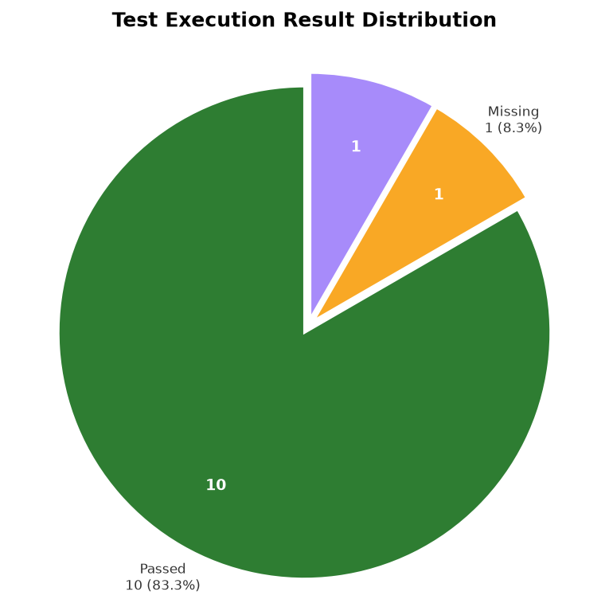
Positive (green) · Negative (red) · Missing/Invalid Data (yellow)

Detailed Test Results
TC ID | Row | Description | Action | Expected | Actual | Status | Remarks | Missing Fields | Invalid Fields
TC01 | 3 | Verifying ACC can be activated above minimum operating speed,  otherwise ACC activation is rejected | ACC_ON | ACC Activated | ACC Activated | Pass | Vehicle Speed 40 km/h At Or Above Minimum Threshold (25 km/h) | — | —
TC02 | 4 | Verifying that ACC correctly stores the driver-selected speed | SET_SPEED | Set Speed = 80 | Set Speed = 80 | Pass | Set Speed Stored | — | —
TC03 | 5 | Verifying that ACC maintains the driver's selected speed when the road ahead is clear | Maintain | Vehicle Maintains 80 km/h | Vehicle Maintains 80 km/h | Pass | No Lead Vehicle - Holding Set Speed | — | —
TC04 | 6 | To verify that ACC maintains a safe distance from the vehicle traveling in front. | Maintain | Safe Distance Maintained | Safe Distance Maintained | Pass | Following Distance Within Safe Range | — | —
TC05 | 7 | Verify that ACC is deactivated when the vehicle requests  to stop ACC operation | ACC_CANCEL | ACC Deactivated | ACC Deactivated | Pass | Cancel Button Pressed | — | —
TC06 | 8 | Check if ACC turns OFF when the driver presses the CANCEL button | ACC_CANCEL | ACC Deactivated | ACC deactivated | Pass | Cancel Button Pressed | — | —
TC07 | 9 | Check if ACC restores the previously selected speed when the  RESUME button is pressed | RESUME | Speed Restored to 80 km/h | Speed Restored to 80 km/h | Pass | Resume Button Pressed | — | —
TC08 | 10 | Verify ACC responds to sudden braking of lead vehicle | Maintain | Emergency Deceleration | Emergency Deceleration | Pass | Critical Distance - Sudden Braking of Lead Vehicle | — | —
TC09 | 11 | Verify that ACC turns OFF and displays a warning when a radar or camera sensor failure occurs | Radar_Failure | ACC Disable, Warning Displayed | ACC Disable, Warning Displayed | Pass | Radar Signal Lost | — | —
TC10 | 12 | Verify that ACC updates the selected speed when the driver presses the "+" or "-" button | Accelator | Manual Override | Manual Override | Invalid Value Error | Invalid Value Error: Column 'Driver Action' unrecognized action 'Accelator' (Test Case TC10, Row 12). | — | Driver Action (unrecognized action 'Accelator')
TC11 | 13 | To verify that ACC is automatically disabled when the vehicle  ignition is turned OFF. | Ignition_OFF | ACC Disabled | ACC Disabled | Pass | Ignition Off - ACC Disengaged | — | —
TC12 | 14 | Verify that ACC automatically stops and resumes the vehicle in stop-and-go traffic  conditions. | Maintain | Vehicle Stops and Resumes | Vehicle Stops and Resumes | Missing Value Error | Missing Value Error: Column 'Lead Vehicle Detected' is empty (Test Case TC12, Row 14). | Lead Vehicle Detected | —

Failed Test Cases
No failed test cases.

Missing Value Errors
TC12 · Row 14
Missing: Lead Vehicle Detected
Details: Missing Value Error: Column 'Lead Vehicle Detected' is empty (Test Case TC12, Row 14).

Invalid Value Errors
TC10 · Row 12
Invalid: Driver Action (unrecognized action 'Accelator')
Details: Invalid Value Error: Column 'Driver Action' unrecognized action 'Accelator' (Test Case TC10, Row 12).

